Dr. Virginia J. Michelich
Associat4e Vice Chancellor for Student Achievement
Academic Affairs 404-463-0502
270 WASHINGTON STREET, S.W.
ATLANTA, GEORGIA 30334 VIRGINIA.MICHELICH@USG.EDU
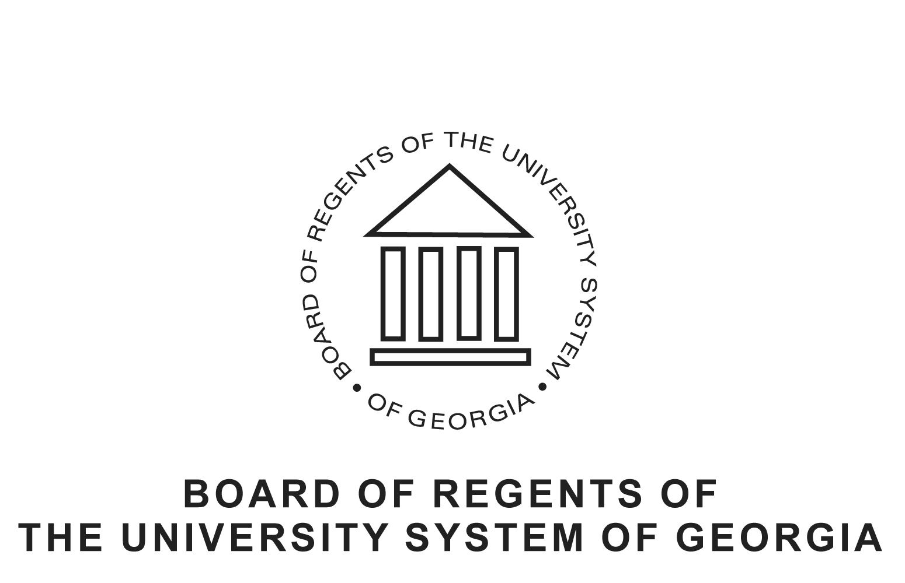
Wednesday, June 22, 2011
Dear President Freeman:
After reviewing the unanimous recommendation of the Regents’ Test Exemption Advisory Committee and consulting with Regent William NeSmith and Chancellor Erroll Davis, I am pleased to inform you that Albany State University’s application for exemption from the Regents’ Test has been approved. The exemption is effective immediately.
The Regents’ Test review committee noted that as reported in its application, ASU has shown a significant improvement in the most recent Regents’ Test performance; a 68.8`% success rate in the Reading portion of the test and 77.8% success rate in the Writing portion of the test. This is significant given the low percentage of students entering who are exempt from Regents” Test.
A well conceived plan is in place at ASU to address reading and writing (communication) skills in ENG 1101 and 1102. The English Department has established communication learning outcomes, goals student performance guidelines, which are consistent with BOR Core Curriculum requirements and Regents’ Test proficiency expectations.
Detailed assessment strategies and tactics are in place to monitor writing and reading skills of students. Students exiting Learning Support who need additional preparation are enrolled in ENG 1125. This course also is available to students exiting
Students exiting Learning Support and/or ENGL 1101 and 1102 with minimal scores may enroll in ENGL 1125, a critical reading course, For students failing to successfully exit ENG 1101 a more comprehensive follow-up course is in place ENGL 1101E. An ENGL 1101 exit exam is required of all enrolled students. This exam accounts for 20% of the course grade. In addition, students have access to two Writing and Reading Labs and on-line writing and reading tutorials.
ASU has provided adequate evidence that a multi-faceted remediation plan is in place for students who fail to satisfy ENGL 1101 and ENGL 1102 course requirements. In addition a multi-faceted set of assessment strategies are in place such as major exit exams in each academic major, implementation of ASU’s SACS QEP program – Writing Realized, which provides for extensive follow-up writing in a variety of courses, and use of the Collegiate Assessment of Academic Proficiency (CAAP) Examination.
If you have any further questions about the exemption, please feel free to contact me.

Sincerely,

Virginia J. Michelich
Associate Vice Chancellor for Student Achievement

